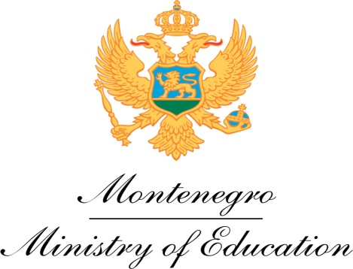

National Erasmus+ Information Day
Venue, Rectorate of the University of Montenegro
November 17, 2014

9.00 – 9.30 Welcome addresses
- Prof. Radmila Vojvodic, rector of the University of Montenegro
- Mrs. Mubera Kurpejovic, Directorate of Directorate for Higher Education
- Mr. Mitja Drobnič, Head of EU Delegation

9.30 - 10.00 Montenegro in Erasmus+ programme
Overview of the Erasmus+ programme and opportunities available to
Montenegrin institutions, Vanja Drljevic, NEO coordinator

10.00-11.00 Opportunities for Montenegrin HEIs in Capacity building in Higher Education, Franco Burgio, Project Officer for Montenegro, EACEA

11.00 – 11.30 Discussion

11.30 – 12.00 Coffee break

12.00 – 12.20 Credit mobility, Vanja Drljevic, NEO coordinator

  - – 12.40 Joint Master Degrees, Ranko Lazovic, NEO

12.40 – 13.00 Discussion

13.00 – 14.00 Lunch break

14.00 – 14.15 Opportunities for Youth in Erasmus +, Ana Škoflek, Contact Point for Erasmus+ Youth in Action, Association for Democratic Prosperity - Zid
14.15 – 14.30 KA3, Montenegrin participation in networks of political support,
Biljana Misovic, Contact point for Eurydice Network, Ministry of Education

14.30 – 15.00 Discussion

15.00 End of the Info day

November 18, 2014

Session on Jean Monnet programme
Venue: Faculty of Economics

15.00 – 15.15 Welcome addresses
EU Delegation to Montenegro, representative
University of Montenegro, representative

15.15 – 15.45 Jean Monnet programme and opportunities for Montenegrin participation, Franco Burgio, Project officer, EACEA

15.45 – 16.15 Presentation of Jean Monnet catedra at the Faculty of Economics, and advice for potential applicants, prof. Gordana Djurovic, Faculty of Economics

16.15 – 17.00 Discussion and open consultations

